Remember the Sabbath Day by Keeping It Holy

Let us not give up meeting together, as some are in the habit of doing, but let us encourage one another—and all the more as you see the Day approaching."
—Hebrews 10:25
The Song of Solomon is the song above all songs, the 10 Commandments the teaching above all teachings, the creed the history above all histories, the Our Father the prayer above all prayers, Baptism and the Lord's Supper the ceremonies above all ceremonies.
—Martin Luther
The Word of God is the true holy thing above all holy things.
—Large Catechism, p.91
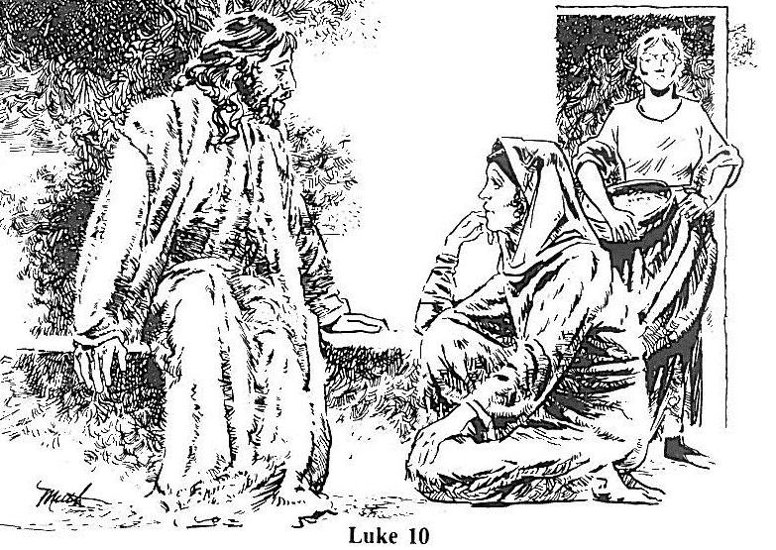
Read Luke 10:38-42
1. Whom did Jesus stop to visit?
2. What was Mary doing?
3. What was Martha doing?
4. How does the artist portray Martha's attitude toward Mary's choice?
5. Was there anything wrong with what Martha chose to do? Why or why not?
6. What did Jesus teach Martha?

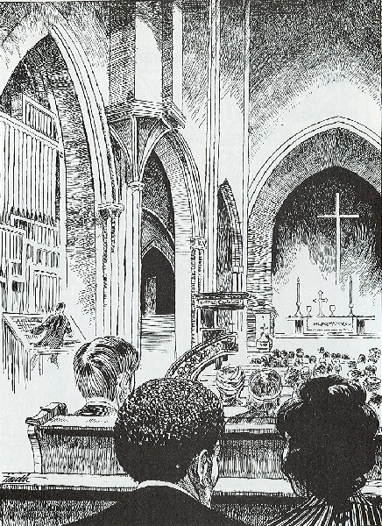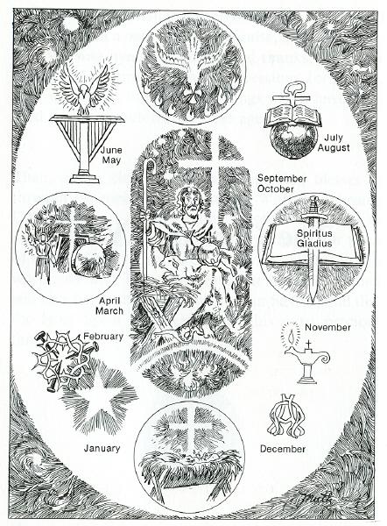

Worship
1. What is the Sabbath day?
2. Do we still observe the Sabbath today? Why or why not?
3. What does the picture show as the center of our worship?
4. What other important things do you see in worship?
5. How does the artist use this picture to portray what John saw in Revelation?

Revelation 5:9 And they sang a new song: “You are worthy to take the scroll and to open its seals, because you were slain, and with your blood you purchased men for God from every tribe and language and people and nation.

My Family and Me: As a family, take pieces of paper and write down the most meaningful part of last Sunday’s worship service. Allow each family member to share their thoughts and react to other responses.

